A Light Introduction to Scrum

Scrum v Waterfall
- Waterfall goes through each of the following steps in full before moving to the next one
    - Plan
    - Build
    - Test
    - Review
    - Deploy
  - Not only can this be very lengthy and inefficient, but it is also rigid and failure-prone
  - As well, it ignores the fact that steps may be affected by what was encountered in future steps
    - Often, things need to revert back step-by-step all the way back to the planning stage
- In Scrum, this process is broken down
  - First, we do minimal planning, just enough to get us started, and undertake a full step cycle just on those small parts
    - Steps
      - Plan
      - Build
      - Test
      - Review
      - Deploy
  - For example, we will take that minimal feature set, plan it out, build it, test, review, and deploy. Then, after we have completed this for the initial feature set, we move on and repeat the cycle for more features.
    - This way, we always have a potentially-shippable product at each step of the way
  - Organized by the Product Managers and Scrum Masters, every few weeks, a certain set of features will be worked on
    - These periods are called sprints
    - The goal is that the product, at the end of each sprint, has made measurable, steady improvements

3 Key Roles in Scrum
- Product Owner
  - Responsible for defining the features that they would like to see in the product
  - Holds responsibility to ensure the application is deployed and built according to the specifications
  - Doesn’t necessarily have to be technically-proficient
  - Holds all accountability from higher-ups
  - Requires strong communication
- Scrum Master
  - A servant leader for the team, responsible for running meetings, keeping the team on track, defining goals for each sprint, etc.
  - Protects team from impediments/obstacles
- Team
  - Can be made up of developers, testers, writers, or anyone else
  - Work can be independent or collaborative, but communication between team members is always important

3 Artifacts
- Product Backlog
  - The Product Owners create a prioritized list of features, known as “user stories”, to be implemented
    - Sort of like a queue that we pick from during each sprint
    - Which features do we need to implement?
- User Stories
  - Outline desired features for the product
  - Follow the following format:
    - “As a _______, I need (or would like) _________ so that ______________”
    - This ensures the feature is well-defined and understood by developers
  - Usually, each sprint, teams try to tackle the highest priority stories in the backlog
- Burndown Charts
  - Show the progress on the completion of tasks in the sprint backlog
  - The burndown chart might show each story or defect and its state, for example
    - Possible States: Analysis, Development, Integration, Verification, etc.

3 Ceremonies in Scrum
- Sprint Planning
  - The Product Owner or Scrum Master meet to discuss the user stories, estimate their relative sizes and time requirements, and assign them in order to give each member of the team clear tasks and directions
- Daily Scrum
  - Team members discuss what they’ve completed, what they’ve been working on, and what they might need help with
- Sprint Review/Retrospective
  - Team demonstrates the completed work to the product owner
  - Team shares successes, difficulties, learnings, etc.

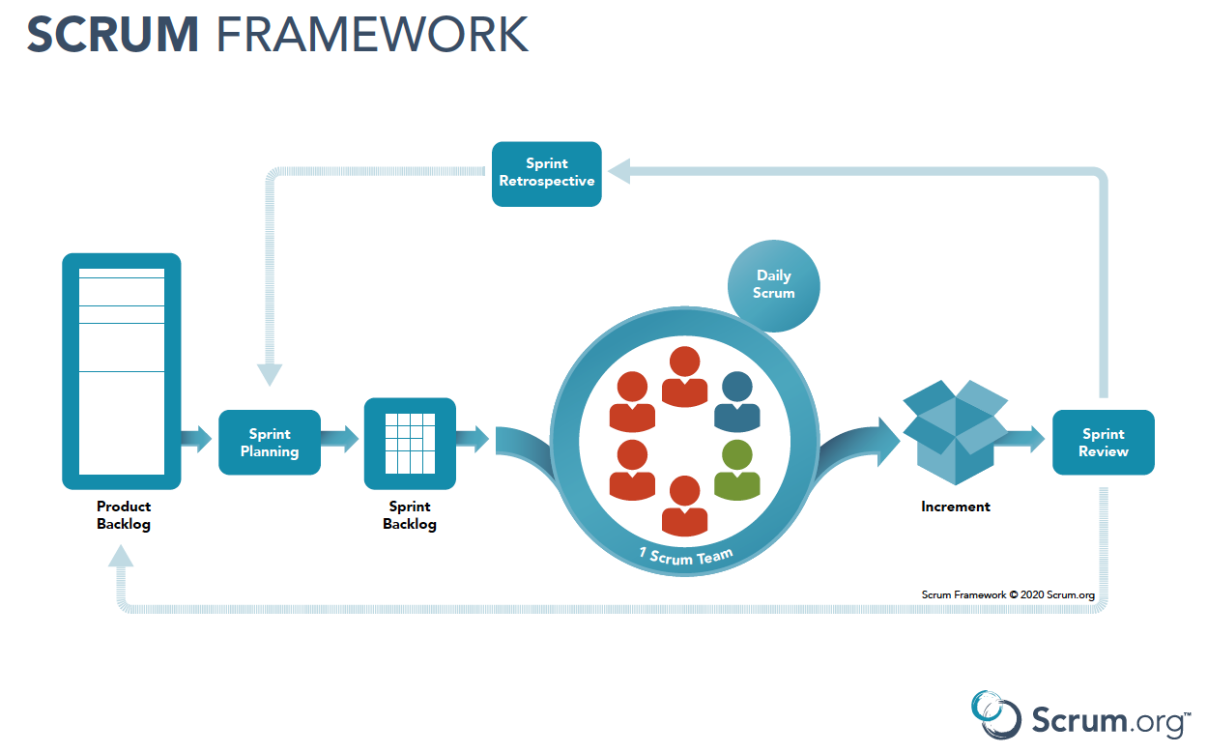

Source: https://www.youtube.com/watch?v=9TycLR0TqFA
(Uzility, 07/26/2014, Introduction to Scrum - 7 Minutes)

More on Agile and Scrum

Stories & Co.
- User Stories
  - Outline desired features for the product
  - Follow the following format:
    - “As a _______, I need (or would like) _________ so that ______________”
    - This ensures the feature is well-defined and understood by developers
  - Usually, each sprint, teams try to tackle the highest priority stories in the backlog
- Epic
  - A large series of work that can be broken down into smaller, more targeted tasks (stories)
  - Like a story for stories
- Feature
  - A chunk of functionality that delivers value to the customer
  - Describes a specific solution, and can often be linked to multiple stories
    - Ex. I want to have a “Hold Call” feature
- Bug
  - A problem or error; an issue encountered
- Defect
  - An issue encountered that supposedly has been fully implemented
- Task
  - A small, distinct piece of work
- Sub-task
  - A small, distinct piece of work that is part of another task

Other Agile Roles (other than big 3)
- Technical & Domain Experts
  - Hold great knowledge of technology as well as stakeholder requirements or expectations
  - Act as oversee-ers and consultants
- Independent Testing/Audit Teams
  - May join Scrum teams in additional to the original testing teams
- Architect Owner
  - May be required for envisioning, planning, and decision-making
  - Technically-knowledgeable and well-experienced
- Integrator
  - Might work between features and subsystems

Agile Metrics
- How do we measure success in an Agile environment? Which numbers do we focus on each sprint?
  - Sprint Burndown Chart
    - Calculates performance and expected output based on time and effort
    - Typically relies on estimations of task hours
  - Velocity
    - A chart displaying the number of commitments for a sprint next to the number of completions
    - The chart also contains the same information for other sprints so we can compare
    - Also helps the Scrum Master better plan for the next sprint. If all commitments are consistently completed, maybe assign more? If completions are consistently falling short, assign less.
  - Lead Time
    - Shows total time from moment a story enters the system in the backlog to the moment it’s completed and present in the official product
    - Basically an end-to-end calculation
  - Cycle Time
    - Measures time for a task to go from “started” or “in-progress” to done
    - Can be helpful for dev performance and blocker frequency
  - Cumulative Flow Diagram
    - Shows status of the sprint
    - The more items we complete, the more the graph goes up
    - The diagram is judged based on its slope, which is always positive
  - Throughput
    - Measures the average tasks completed per unit time

Jira Features
- Agile Board
  - A visual representation of progress of a software project
  - Divided into three colums
    - To-Do
    - In-Progress
    - Done
  - Helps with transparency and organization

Source: https://www.youtube.com/watch?v=KNBHQ0pyaG8&list=PLFx6zWdaixYt0Rew1MGOB9w-CmhV0Cg5E&index=29&ab_channel=InvensisLearning
(Invensis Learning, 02/24/2021, Agile Methodology Tutorial for Beginners | Jira Tutorial | Agile Methodology Explaine)

